- Develop a comprehensive test plan document for a chosen application, such as a Library Management System, outlining the various testing strategies, methodologies, and criteria to ensure thorough evaluation and validation of the system&#39;s functionality.

Code:
package npkb;
import java.util.Scanner; public class npkb {
public static void main(String[] args) { Scanner sc = new Scanner(System.in);
String username, password, bookName; int choice;
int totalBooks = 0;
int borrowedBooks = 0;

System.out.println("===== LIBRARY MANAGEMENT SYSTEM =====");

do {
System.out.println("\n1. User Registration / Login"); System.out.println("2. Search for a Book"); System.out.println("3. Borrow a Book"); System.out.println("4. Return a Book"); System.out.println("5. Add a New Book"); System.out.println("6. Display Number of Books"); System.out.println("7. Generate Borrowing Report"); System.out.println("8. Display Book ID"); System.out.println("9. Security Settings"); System.out.println("10. Membership Renewal / Payment");

System.out.println("0. Exit");

System.out.print("\nEnter your choice: "); choice = sc.nextInt();
sc.nextLine(); switch (choice) {
case 1:
System.out.print("Enter username: "); username = sc.nextLine();

System.out.print("Enter password: "); password = sc.nextLine();

if (!username.isEmpty() && !password.isEmpty()) { System.out.println("Login successful!");
} else {
System.out.println("Invalid username or password!");
}
break;

case 2:
System.out.print("Enter book name to search: "); bookName = sc.nextLine();
System.out.println("Book search completed for: " + bookName); break;

case 3:
if (totalBooks > borrowedBooks) { System.out.print("Enter book name to borrow: "); bookName = sc.nextLine();
borrowedBooks++;
System.out.println("Book borrowed successfully!");
} else {
System.out.println("No books available to borrow.");
}
break; case 4:

if (borrowedBooks > 0) {
System.out.print("Enter book name to return: "); bookName = sc.nextLine();
borrowedBooks--;
System.out.println("Book returned successfully!");
} else {
System.out.println("No borrowed books to return.");
}
break;

case 5:
System.out.print("Enter number of books to add: "); int count = sc.nextInt();

if (count > 0) { totalBooks += count;
System.out.println("Books added successfully!");
} else {
System.out.println("Invalid book count!");
}
break;

case 6:
System.out.println("Total books: " + totalBooks); System.out.println("Borrowed books: " + borrowedBooks); System.out.println("Available books: "
+ (totalBooks - borrowedBooks)); break;

case 7:
System.out.println("\n===== BORROWING REPORT ====="); System.out.println("Total books: " + totalBooks); System.out.println("Borrowed books: " + borrowedBooks); System.out.println("Available books: "
+ (totalBooks - borrowedBooks)); break;

case 8:
System.out.print("Enter book name: "); bookName = sc.nextLine();

System.out.println("Book ID: LIB101"); System.out.println("Book name: " + bookName); break;

case 9:
System.out.println("===== SECURITY SETTINGS ====="); System.out.println("Password protection enabled."); System.out.println("User authentication required.");
break;

case 10:
System.out.println("1. Membership Renewal"); System.out.println("2. Payment"); System.out.print("Enter option: ");
int paymentChoice = sc.nextInt();

if (paymentChoice == 1) {
System.out.println("Membership renewed successfully!");
} else if (paymentChoice == 2) { System.out.println("Payment completed successfully!");
} else {
System.out.println("Invalid payment option!");
}
break;

case 0:
System.out.println("Exiting Library Management System."); break;

default:
System.out.println("Invalid choice! Try again.");
}

} while (choice != 0);

sc.close();
}
}

Report table:

S.  No. | Feature | Test Scenario | Expected Result
1 | Login | Enter valid username and password | User logs in successfully
2 | Book Search | Search for an existing book | Correct book details are displayed
3 | Borrow Book | Borrow an available book | Book is issued successfully
4 | Return Book | Return an issued book | Book status is updated
5 | Fine Calculation | Return a book after the due date | Fine is calculated correctly
6 | Availability | Check the availability of a book | Correct availability is displayed

Testing Approach: Functional testing, validation testing, usability testing, integration testing, and regression testing.
Result: A comprehensive test plan was prepared for the major functions of the Library Management System.

Code output:
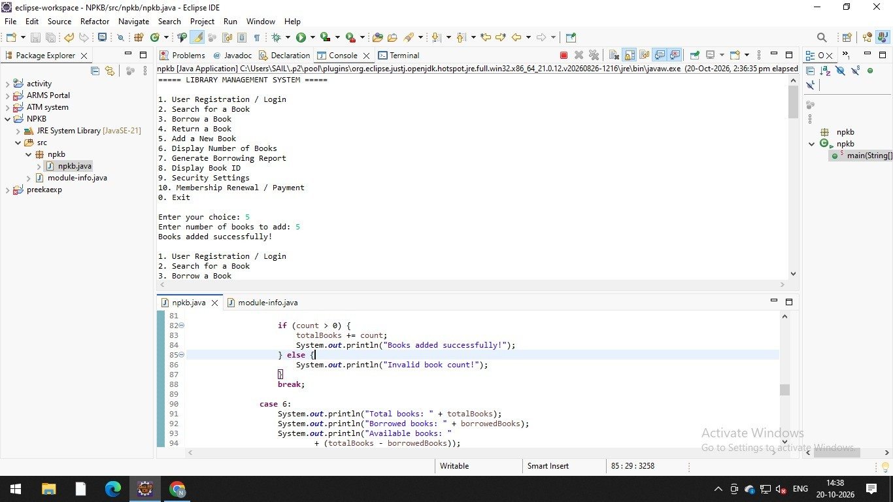
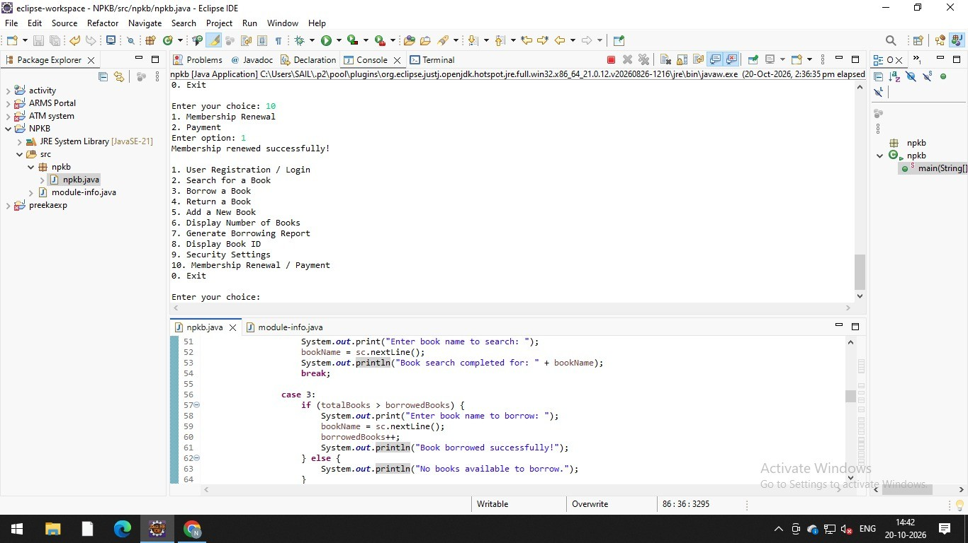

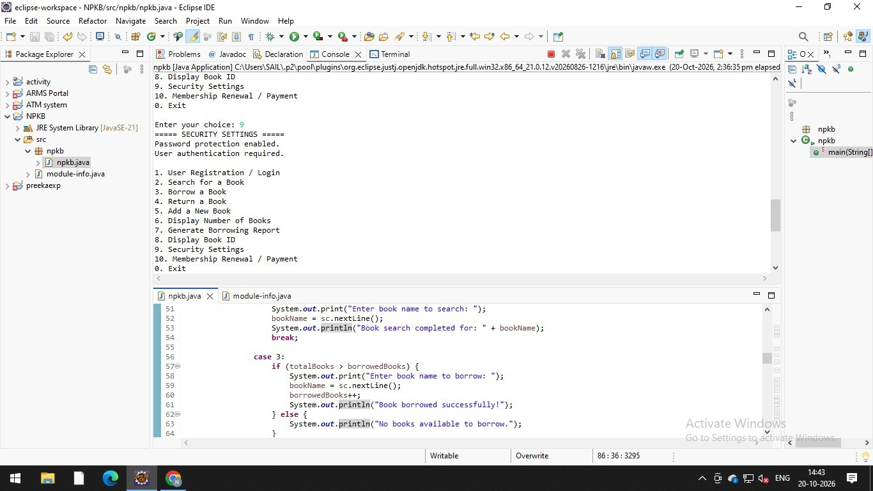

Write a case study to identify and analyze the requirements of a Railway Reservation System and prepare positive test scenarios and test cases for the application.

Code:
package npkb;
import java.util.Scanner; import java.time.LocalDate; import java.util.Random;

public class npkb{

public static void main(String[] args) {

Scanner sc = new Scanner(System.in); Random random = new Random();

String username = ""; String password = ""; String source = ""; String destination = ""; String journeyDate = ""; String travelClass = "";
String passengerName = ""; String berth = "";
boolean registered = false; boolean loggedIn = false; boolean paymentDone = false; String pnr = "";

int choice;

System.out.println("===== RAILWAY RESERVATION SYSTEM =====");

do {
System.out.println("\n1. User Registration"); System.out.println("2. User Login"); System.out.println("3. Train Search"); System.out.println("4. Journey Date Selection"); System.out.println("5. Class Selection"); System.out.println("6. Passenger Details");

System.out.println("7. Berth Preference"); System.out.println("8. Payment"); System.out.println("9. PNR Generation"); System.out.println("10. Ticket Confirmation"); System.out.println("0. Exit"); System.out.print("\nEnter your choice: "); choice = sc.nextInt();
sc.nextLine(); switch (choice) {

case 1:
System.out.print("Enter username: "); username = sc.nextLine();

System.out.print("Enter email: "); String email = sc.nextLine();

System.out.print("Enter 10-digit mobile number: "); String mobile = sc.nextLine();

System.out.print("Create password: "); password = sc.nextLine();

if (!username.isEmpty()
&& email.contains("@")
&& mobile.matches("[0-9]{10}") && !password.isEmpty()) {
registered = true; System.out.println("Registration successful!");
} else {
System.out.println("Enter valid registration details.");
}
break;

case 2:
System.out.print("Enter username: "); String loginUser = sc.nextLine();

System.out.print("Enter password: "); String loginPass = sc.nextLine();

if (registered && loginUser.equals(username) && loginPass.equals(password)) {
loggedIn = true; System.out.println("Login successful!");
} else {
System.out.println("Please register or enter correct credentials.");
}
break;

case 3:
if (!loggedIn) {
System.out.println("Please login first."); break;
}
try {
LocalDate date = LocalDate.parse(journeyDate);

if (date.isAfter(LocalDate.now())) { System.out.println("Journey date selected successfully.");
} else {
System.out.println("Select a future journey date.");
}
} catch (Exception e) { System.out.println("Invalid date format.");
}
break;

case 5:
System.out.println("Select class:"); System.out.println("1. SL"); System.out.println("2. 3A"); System.out.println("3. 2A"); System.out.println("4. 1A"); System.out.print("Enter choice: ");

int classChoice = sc.nextInt(); sc.nextLine();

switch (classChoice) {

case 1: travelClass = "SL"; break; case 2: travelClass = "3A"; break; case 3: travelClass = "2A"; break; case 4: travelClass = "1A"; break; default:
travelClass = "";
System.out.println("Invalid class selection.");
}

if (!travelClass.isEmpty()) { System.out.println("Selected class: " + travelClass); System.out.println("Availability: Available (Demo)");
}
break; case 7:
System.out.println("1. Lower"); System.out.println("2. Middle"); System.out.println("3. Upper"); System.out.print("Select berth preference: ");

int berthChoice = sc.nextInt(); sc.nextLine();

switch (berthChoice) {
case 1: berth = "Lower"; break; case 2: berth = "Middle"; break; case 3: berth = "Upper"; break; default: berth = "";
}

if (!berth.isEmpty()) {
System.out.println("Berth preference saved: " + berth);
} else {
System.out.println("Invalid berth preference.");
}
break;

case 8:
System.out.println("Select payment method:"); System.out.println("1. UPI");

System.out.println("2. Net Banking"); System.out.print("Enter choice: ");

int payChoice = sc.nextInt(); sc.nextLine();

if (payChoice == 1 || payChoice == 2) { paymentDone = true;
System.out.println("Demo payment successful!");
} else {
System.out.println("Invalid payment method.");
}
break;

case 9:
if (paymentDone) {
pnr = String.format("%010d", random.nextLong(1, 10_000_000_000L));
System.out.println("PNR generated successfully: " + pnr);
} else {
System.out.println("Complete payment before PNR generation.");
}
break;

case 10:
if (paymentDone && !pnr.isEmpty()) {
System.out.println("===== TICKET CONFIRMATION =====");
System.out.println("Passenger: " + passengerName); System.out.println("Source: " + source); System.out.println("Destination: " + destination); System.out.println("Journey Date: " + journeyDate); System.out.println("Class: " + travelClass); System.out.println("Berth: " + berth); System.out.println("PNR: " + pnr); System.out.println("Ticket confirmed (Demo)."); System.out.println("PDF/SMS service is simulated.");
} else {
System.out.println("Complete payment and generate PNR first.");
}
break;

case 0:
System.out.println("Thank you for using Railway Reservation System."); break;

default:
System.out.println("Invalid choice. Try again.");
}

} while (choice != 0);

sc.close();
}
}

Report:

S.  No. | Feature | Test Scenario | Expected Result
1 | Login | Enter valid login credentials | User logs in successfully
2 | Train Search | Enter valid source and destination | Available trains are displayed
3 | Journey Date | Select a valid future journey date | Trains for the selected date are displayed
4 | Seat Availability | Select a train and class | Seat availability is displayed
5 | Passenger Details | Enter valid passenger information | Details are accepted
6 | Ticket Booking | Confirm booking with valid details | Ticket is booked and PNR is generated
7 | Payment | Complete payment successfully | Booking is confirmed
8 | Booking History | View an existing booking | Ticket and PNR details are displayed

Result: Positive test scenarios and test cases were prepared for the main functions of the Railway Reservation System.

Code output:

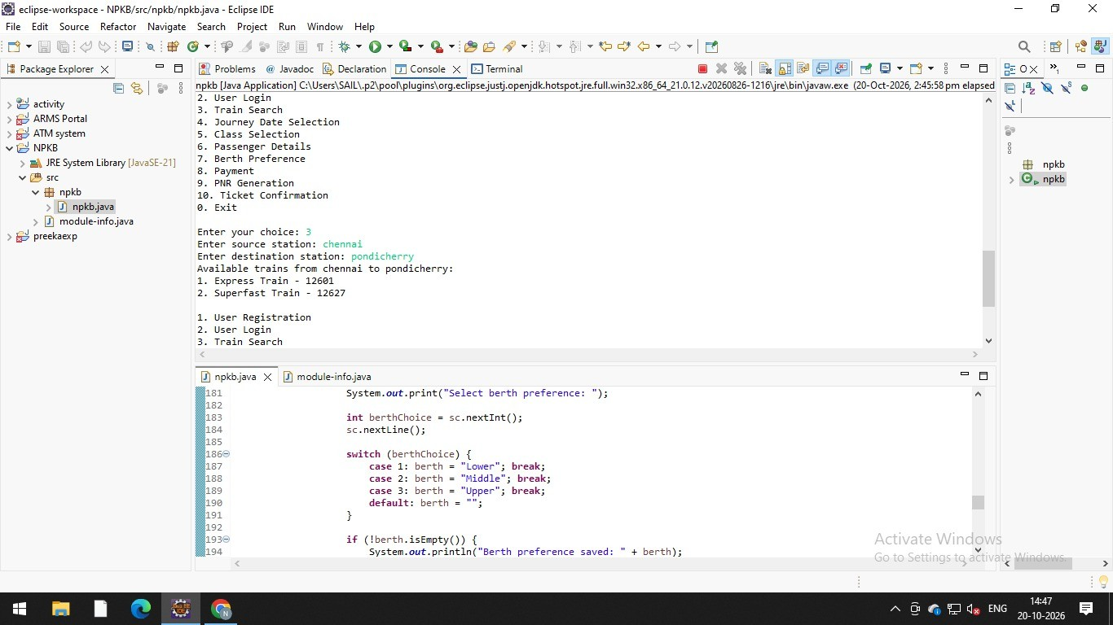

To find the Nth term of the Fibonacci series and validate the output using JUnit assertions.

Code:
package npkb;
import java.util.Scanner; import java.time.LocalDate;

public class npkb{

public static void main(String[] args) {

Scanner sc = new Scanner(System.in); int choice;

do {
System.out.println("\n===== RAILWAY RESERVATION SYSTEM =====");
System.out.println("1. User Registration - Invalid Email"); System.out.println("2. User Login - Wrong Password"); System.out.println("3. Train Search - Same Station"); System.out.println("4. Journey Date - Past Date"); System.out.println("5. Passenger Age Validation"); System.out.println("6. Passenger Name Validation"); System.out.println("7. Passenger Booking Limit"); System.out.println("8. Payment Failure"); System.out.println("9. PNR Length Validation"); System.out.println("10. Ticket Cancellation After Departure"); System.out.println("0. Exit");

System.out.print("Enter your choice: "); choice = sc.nextInt();
sc.nextLine(); switch (choice) {
case 1:
System.out.print("Enter email: "); String email = sc.nextLine();

if (!email.matches("^[A-Za-z0-9._%+-]+@[A-Za-z0-9.-]+\\.[A-Za-z]{2,}$")) {

System.out.println("Error: Invalid email format.");
} else {
System.out.println("Email format is valid.");
}
break;

case 2:
String correctPassword = "train123";

System.out.print("Enter password: "); String password = sc.nextLine();

if (!password.equals(correctPassword)) { System.out.println("Invalid Credentials"); System.out.println("Login denied.");
} else {
System.out.println("Login successful.");
}
break;

case 3:
System.out.print("Enter source station: "); String source = sc.nextLine();

System.out.print("Enter destination station: "); String destination = sc.nextLine();

if (source.equalsIgnoreCase(destination)) { System.out.println(
"Error: Source and destination cannot be the same.");
} else {
System.out.println("Route details accepted.");
}
break;

case 4:
System.out.print("Enter journey date (YYYY-MM-DD): "); String dateInput = sc.nextLine();

try {

LocalDate journeyDate = LocalDate.parse(dateInput);

if (journeyDate.isBefore(LocalDate.now())) { System.out.println(
"Error: Past dates are not allowed.");
} else {
System.out.println("Journey date accepted.");
}
} catch (Exception e) {
System.out.println("Error: Invalid date format.");
}
break;

case 5:
System.out.print("Enter passenger age: ");

try {
int age = Integer.parseInt(sc.nextLine());

if (age <= 0) { System.out.println(
"Error: Age must be greater than zero.");
} else {
System.out.println("Passenger age accepted.");
}
} catch (NumberFormatException e) { System.out.println("Error: Enter a valid numeric age.");
}
break;

case 6:
System.out.print("Enter passenger name: "); String name = sc.nextLine();

if (!name.matches("[A-Za-z ]+")) { System.out.println(
"Error: Name must contain only letters and spaces.");
} else {
System.out.println("Passenger name accepted.");
}

break;

case 7:
System.out.print("Enter number of passengers: ");

try {
int passengers = Integer.parseInt(sc.nextLine());

if (passengers > 6) { System.out.println(
"Error: Maximum 6 passengers allowed.");
} else if (passengers <= 0) { System.out.println(
"Error: At least one passenger is required.");
} else {
System.out.println(
"Passenger count accepted: " + passengers);
}
} catch (NumberFormatException e) { System.out.println("Error: Enter a valid number.");
}
break;

case 8:
System.out.println("Enter payment card details (demo):"); System.out.print("Is the card expired? (yes/no): ");
String expired = sc.nextLine();

if (expired.equalsIgnoreCase("yes")) { System.out.println("Transaction Failed"); System.out.println("Please use a valid payment method.");
} else if (expired.equalsIgnoreCase("no")) { System.out.println("Demo payment successful.");
} else {
System.out.println("Invalid input.");
}
break;

case 9:
System.out.print("Enter PNR number: ");

String pnr = sc.nextLine();

if (!pnr.matches("[0-9]{10}")) { System.out.println("Invalid PNR");
} else {
System.out.println("PNR format is valid.");
}
break;

case 10:
System.out.print(
"Has the train already departed? (yes/no): "); String departed = sc.nextLine();

if (departed.equalsIgnoreCase("yes")) { System.out.println(
"Error: Ticket cancellation is not allowed after departure.");
} else if (departed.equalsIgnoreCase("no")) { System.out.println(
"Ticket cancellation can proceed (demo).");
} else {
System.out.println("Invalid input.");
}
break;

case 0:
System.out.println("Exiting Railway Negative Test System."); break;

default:
System.out.println("Invalid choice. Try again.");
}

} while (choice != 0);

sc.close();
}
}

Report:

S.  No. | Test Scenario | Input(N) | Expected Result | JUnit Assertion
1 | First term | 1 | 0 | assertEquals(0, fibonacci(1));
2 | Second term | 2 | 1 | assertEquals(1, fibonacci(2));
3 | Third term | 3 | 1 | assertEquals(1, fibonacci(3));
4 | Fifth term | 5 | 3 | assertEquals(3, fibonacci(5));
5 | Seventh term | 7 | 8 | assertEquals(8, fibonacci(7));
6 | Tenth term | 10 | 34 | assertEquals(34, fibonacci(10));
7 | Invalid input | 0 | Validation error or exception | assertThrows(...)
Note: The assertThrows(...) syntax depends on the JUnit version. The expected results above are test expectations; mark tests as passed only after running them.

Result: Fibonacci test cases were prepared to validate the output for different inputs using JUnit assertions.

Code output:
